‘When Things Go Wrong’
Lesson Plan (Key Stage 3 & 4)

Children are becoming more aware of online risks but many still lack experience when it comes to making decisions and managing their feelings when something goes wrong.

This lesson includes three case studies inspired by a composite of real events. They cover; Sexting, Sextortion and Anonymous messaging. (NB: Staff and Parents have access to advice on ‘Anonymous Messaging on the ‘Safer Schools’ App. Pupils do not have access to this information)

Reassure pupils that if something does go wrong online, everyone including teachers, parents, carers and the police will simply want to help them. For more information, visit the link at the bottom of the page..

A common thread in each case study is that when something goes wrong online, they should tell an adult they trust as soon as possible. It’s a good idea to discuss what we mean by a trusted adult.

Early intervention is key, the sooner they tell a trusted adult, the sooner steps can be taken to sop the image, or hurtful comments, being circulated.

Slide 1 – Title Page
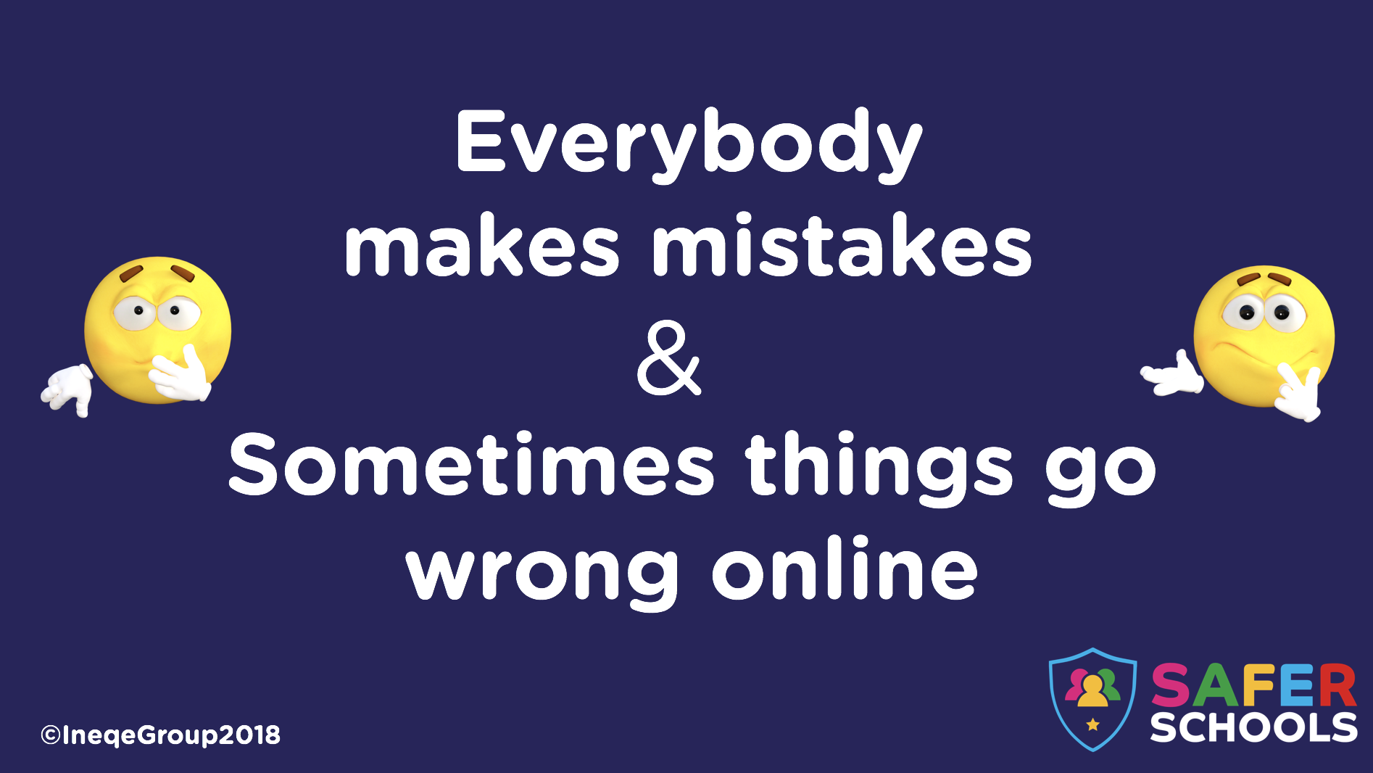 | ‘Sometimes things go wrong online.’ Zooms up with a separate click  Prompt: Have you ever made a mistake?  It’s important to put this in context. We ALL make mistakes and learning from them is what matters
NOTES:
___________________________________________________________________________
___________________________________________________________________________
______________________________________________________________________________________________________________________________________________________
___________________________________________________________________________
_________________________________________________________________________________________________________________________________________________________________________________________________________________________________
_________________________________________________________________________________________________________________________________________________________________________________________________________________________________
_________________________________________________________________________________________________________________________________________________________________________________________________________________________________
______________________________________________________________________________________________________________________________________________________
Slide 2 – Introduction to the Internet
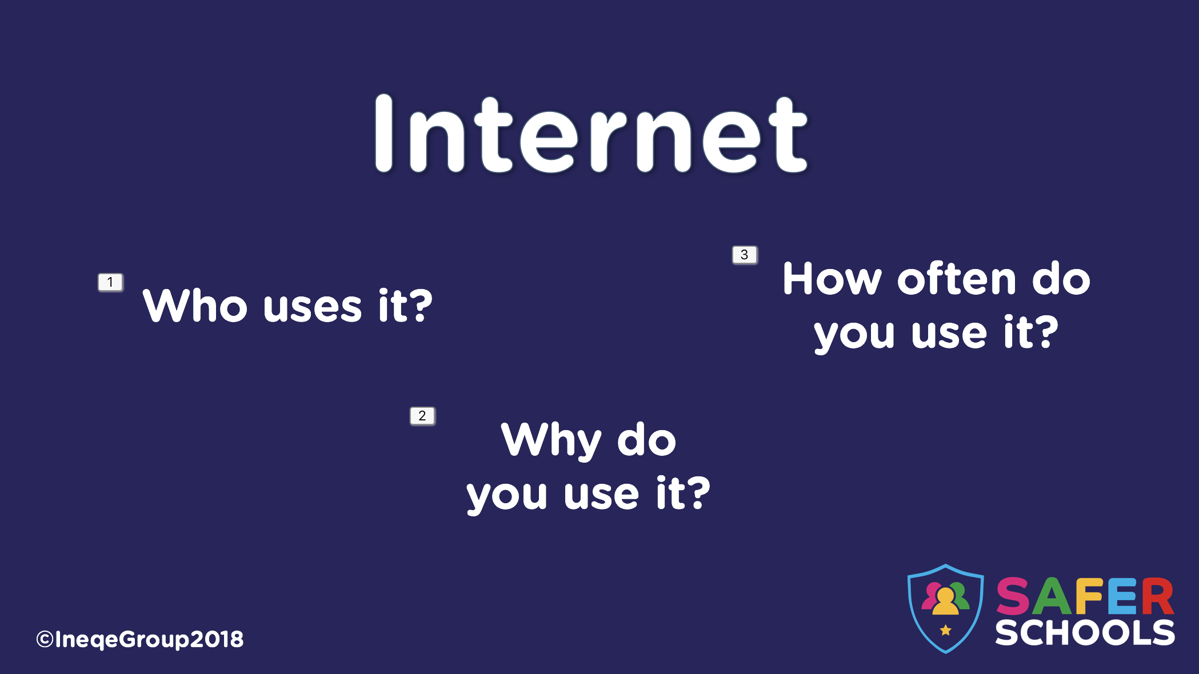 | Each of these three titles will zoom in separately.  - Who uses it.  - Almost 4 billion people use the internet worldwide.  - 94.8% of the UK population is online.  - Why do you use it?  - Encourage pupils to be open as to why they use it.  - Eg. Play Games, talk to friends and family etc.  - How often do you use it?  - Most people can spend 257 minutes per day on screen time each day before it has a negative impact on their health and wellbeing. (4 and a half hours)  Prompt: You could explain different types of screen time. i.e. Face timing family in a different country is different from a gaming or social media addiction.
NOTES:
___________________________________________________________________________
___________________________________________________________________________
____________________________________________________________________________________________________________________________________________________________________________________________________________________________________________________________________________________________________________
___________________________________________________________________________
_________________________________________________________________________________________________________________________________________________________________________________________________________________________________
Slide 3 – What do we do online?
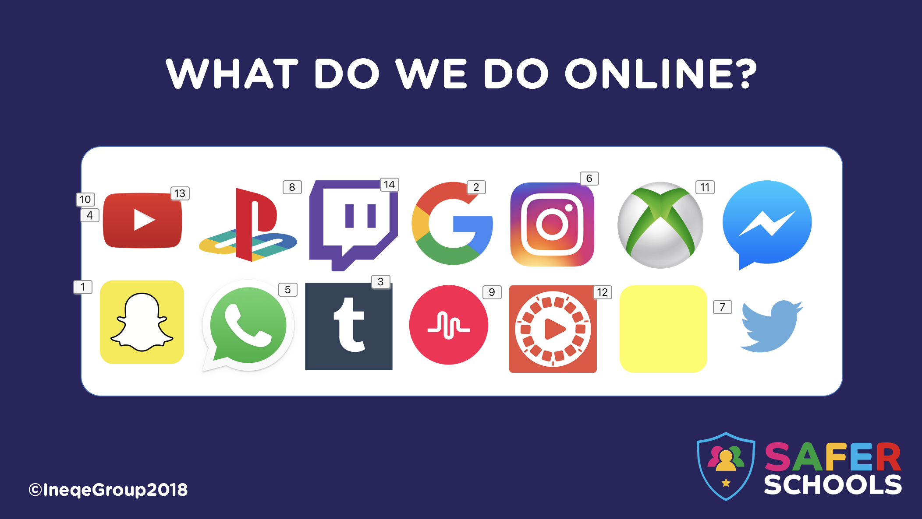 | Each of these icons will appear separately.  - Before you start clicking through them, encourage pupils to talk about some of the apps and websites they use. These are some of the more popular apps at the moment.  - Snapchat  - Instagram  - Musical.ly  - Whatsapp  - Tumblr  - Google  - Twitter  - Flipagram  - Youtube  - Messenger (Facebook)  - Yubo (formerly Yellow)  - Xbox  - Playstation  - Twitch.tv  NB: Teachers, Parents, Carers and Pupils can find more information on some of these apps in the ‘Social Media’ and ‘Gaming’ sections of the Safer Schools App.
NOTES:
___________________________________________________________________________
___________________________________________________________________________
_____________________________________________________________________________________________________________________________________________________________________________________________________________________________________________________________________________________________________________________________________________________________________________________________________________________________________________________________________________________________________________________________________________
Slide 4 – Case Study 1
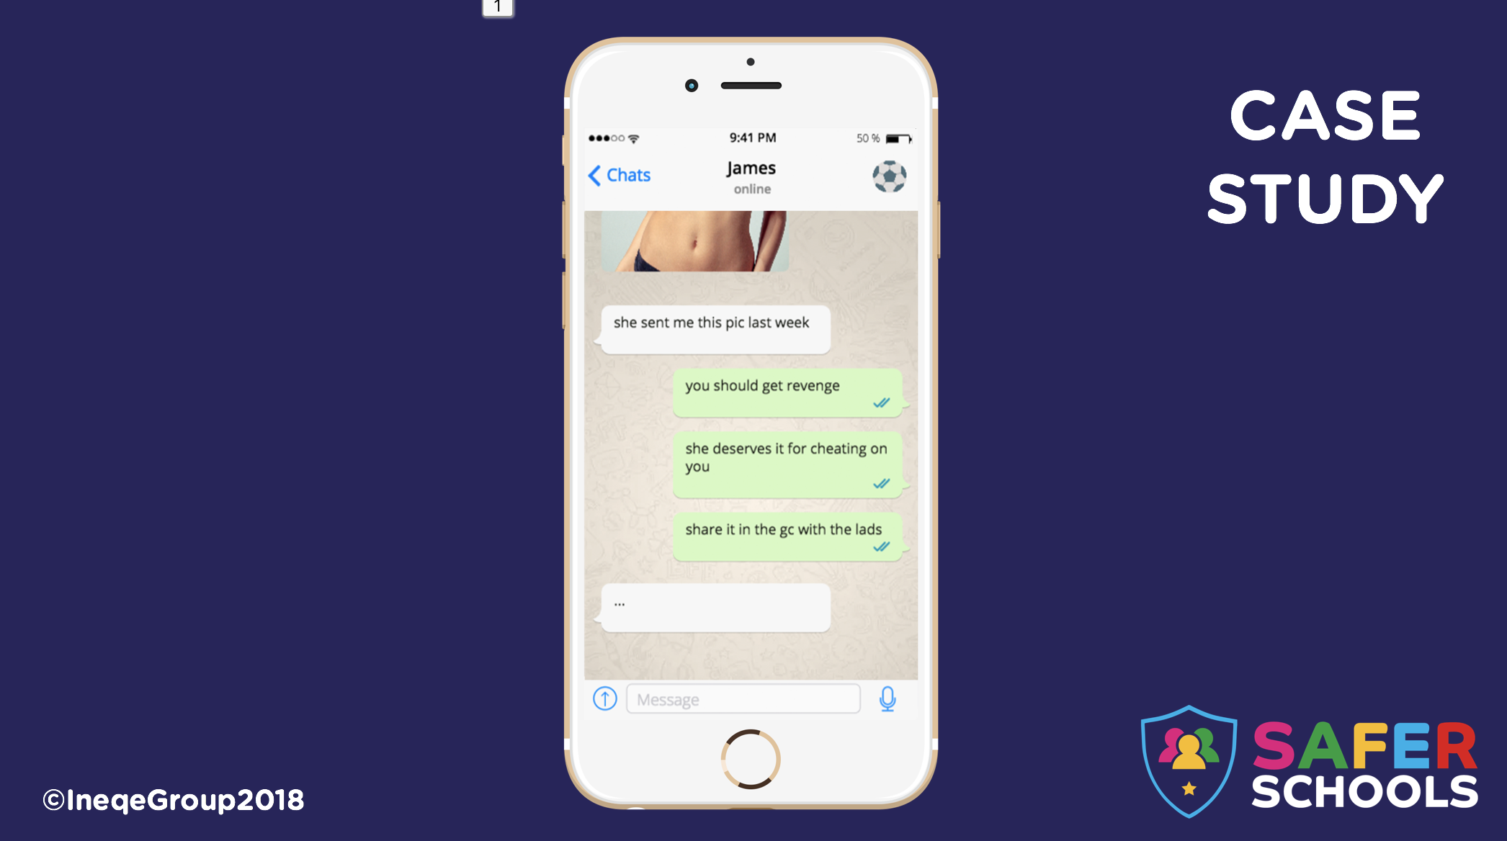 | Case Study 1 deals with Sexting and Sharing inappropriate images.  The phone screen will zoom in with a click, allow students enough time to read through the messages on the screen.  Questions you could ask:  - When James’ girlfriend sent this image, do you think she consented? Would she give her consent now?  - Consent is a vital aspect of sharing images online. Pupils can find more information on this in the ‘Digital Images’ section of the Safer Schools app.  - Why has James shared this image with his friend (Hurt at break up? Jealous? Angry? Bullying? Revenge?)  - Is the person James is talking to being a good friend?  NB: Teachers, Parents, Carers, Middle Secondary Pupils and Upper Secondary Pupils can find more information ‘Sexting’ in the Safer Schools App.  Lower Secondary pupils can find information on ‘Sexting’ in the ‘Digital Images’ section of their app but they do not have access to information on ‘Sextortion’
NOTES:
___________________________________________________________________________
___________________________________________________________________________
_________________________________________________________________________________________________________________________________________________________________________________________________________________________________
Slide 5 – What happened
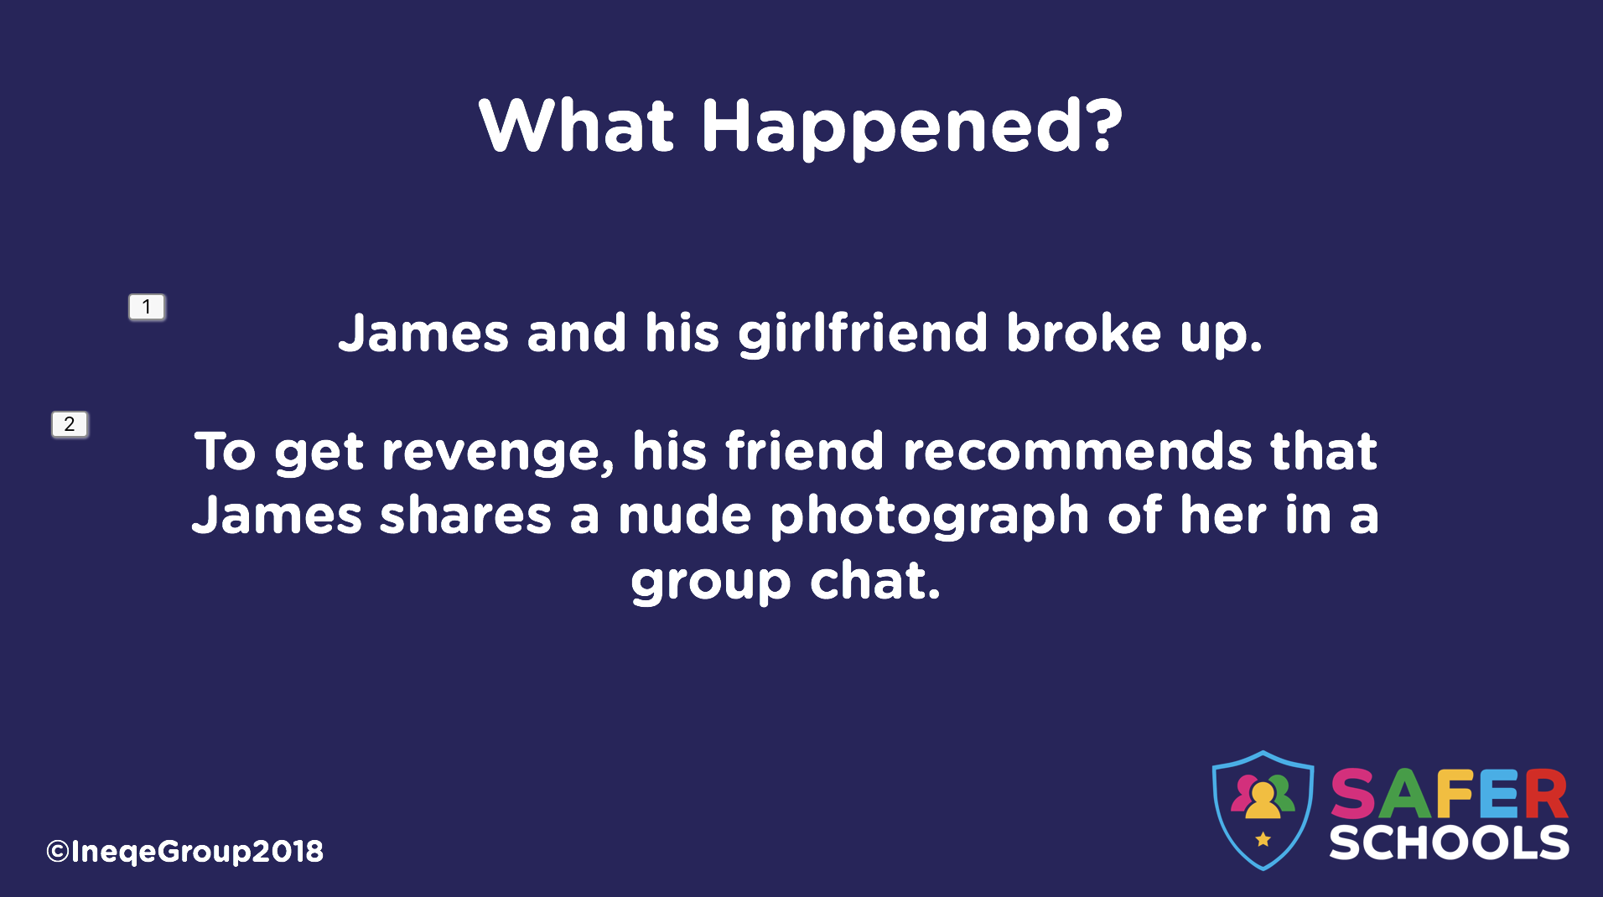 | This slide explains the context of the case study.  The two sentences appear on with separate clicks.  - James and his girlfriend broke up.  - To get back at her, his friend suggests that James shares a nude photograph of her in a group chat.
NOTES:
___________________________________________________________________________
___________________________________________________________________________
___________________________________________________________________________________________________________________________________________________________________________________________________________________________________________________________________________________________________________________________________________________________________________________________________________________________________________________________________________________________________________________________________________________________________________________________________________________________________________________________________________________________________
____________________________________________________________________________________________________________________________________________________________________________________________________________________________________________________________________________________________________________
Slide 6 - Discuss
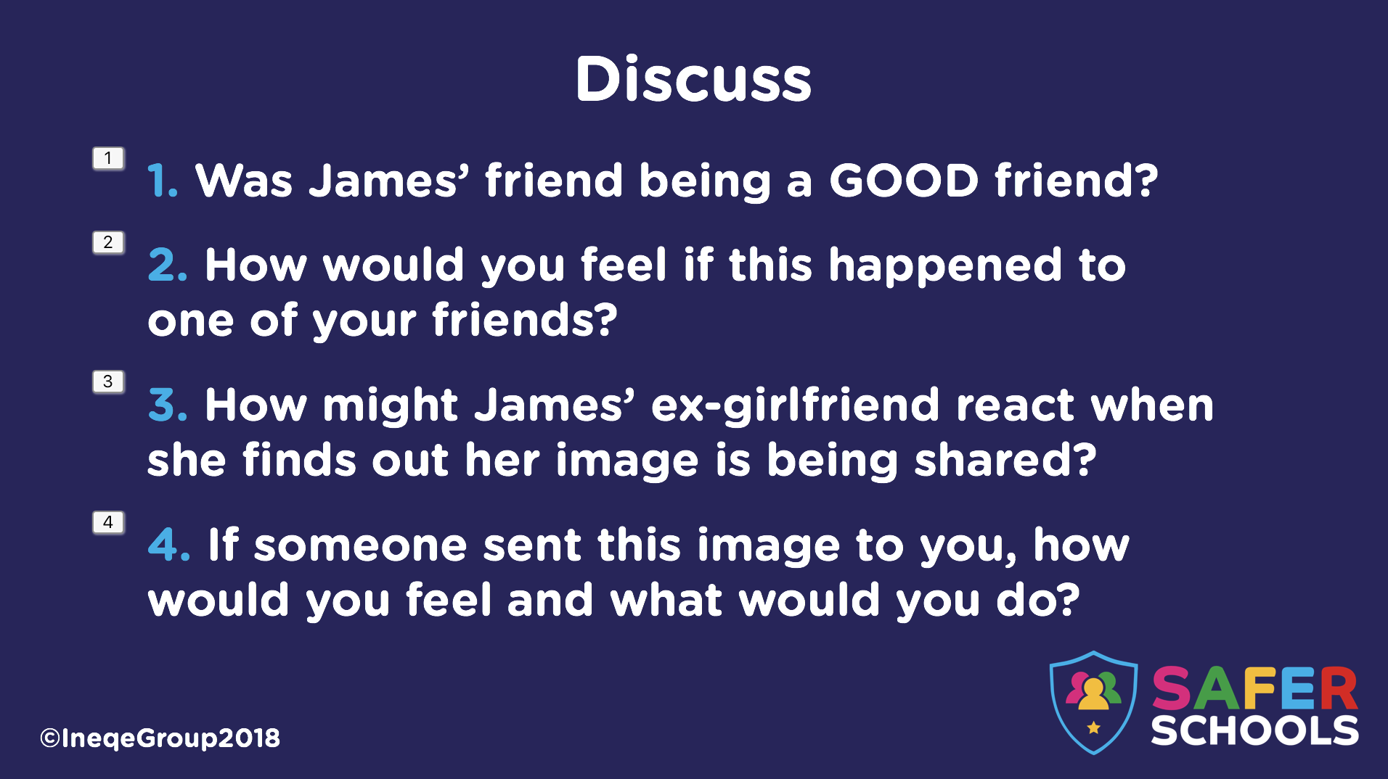 | This slide gives pupils the opportunity to discuss issues surrounding sharing inappropriate or explicit images.  - Was James’ friend being a GOOD friend?  - This reinforces a point mentioned on slide 4.  - How would you feel if this happened to one of your friends?  - Although they may it funny, it’s important to reinforce how a victim of this behaviour would feel (Embarrassed, shamed, isolated and upset etc.)  - How might James’ ex-girlfriend react when she finds out her image is being shared?  - Upset, angry, scared, insecure, desperate, suicidal?  - If someone sent this image to you, how would you feel and what would you do?  - They should delete it, not pass it on and tell a trusted adult.  NB: Teachers, Parents, Carers and Pupils can find more information on ‘Consent’ in the ‘Digital Images’ section of the Safer Schools App.
NOTES:
___________________________________________________________________________
___________________________________________________________________________
_______________________________________________________________________________________________________________________________________________________________________________________________________________________________________________________________________________________________________________________________________________________________________________________
Slide 7 – What you can do
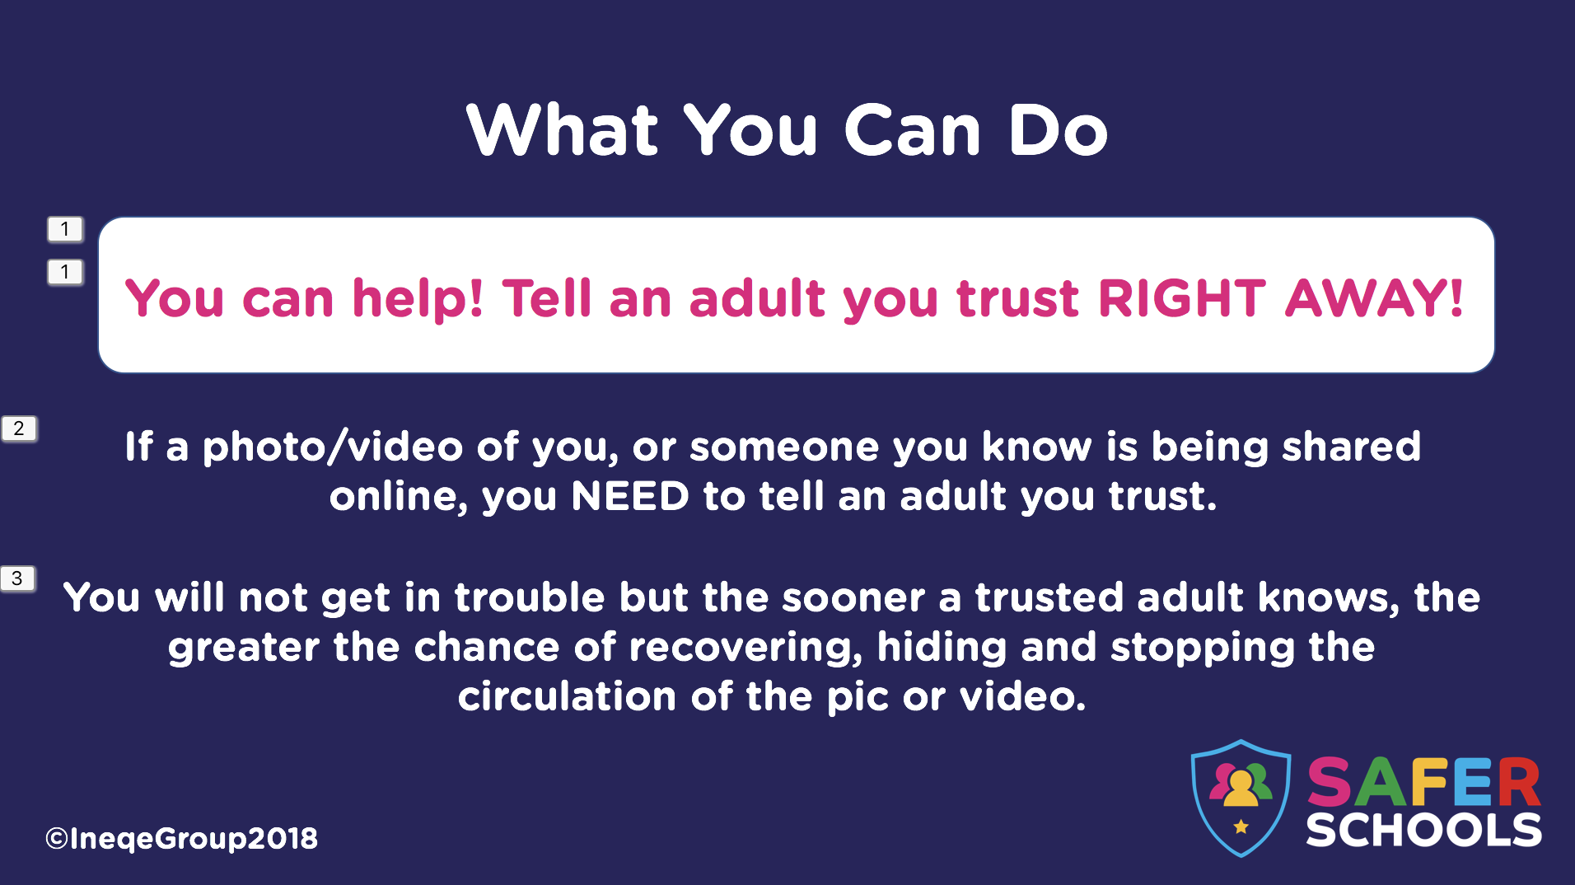 | Each of these three titles will appear separately.  - You can help! Reinforce that they should tell an adult they trust right away.  - Ask – Who could they tell?  - & 3. Reinforce that everyone will want to help
NOTES:
___________________________________________________________________________
___________________________________________________________________________
__________________________________________________________________________________________________________________________________________________________________________________________________________________________________________________________________________________________________________________________________________________________________________________________________________________________________________________________________________________________________________________________________________________________________________________________________________________________________________________________________________________________________________________________________________________________________________________________________________________________________________________________________________________________________________________________________________________________________________________________________________________________________________________________________________________________
Slide 8 – How to stop it spreading
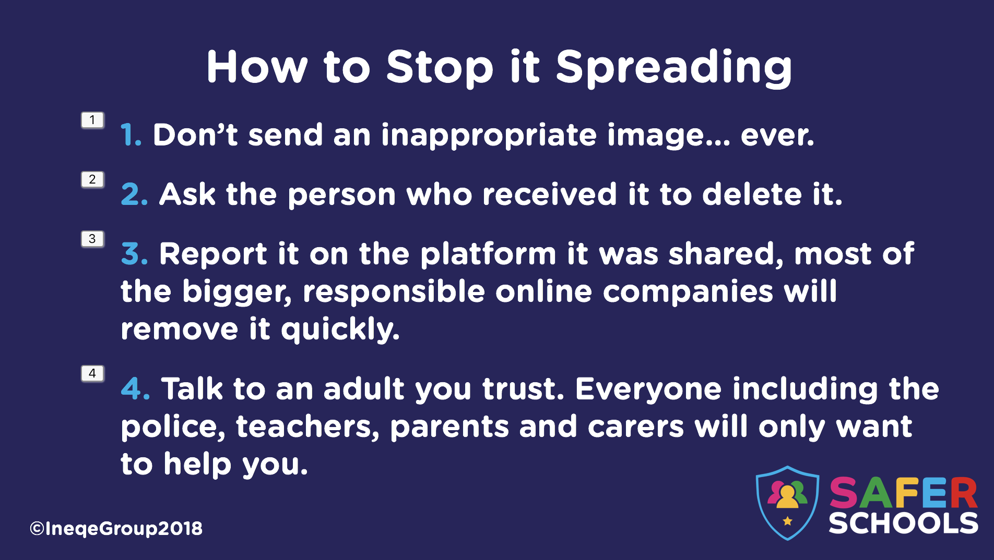 | Each of these four titles appear in separately.  - Never send an image you wouldn’t want your parents, carers, teachers and the newspapers to see.  - Ask the person to delete it.  - Report it on the online platform if possible.  - Talk to an adult you trust. Everyone including the police, teachers, parents and carers will want to help you.  NB: Teachers, Parents, Carers and Pupils can find more information on ‘Sharing’ in the ‘Digital Images’ section of the Safer Schools App.
NOTES:
___________________________________________________________________________
___________________________________________________________________________
____________________________________________________________________________________________________________________________________________________________________________________________________________________________________________________________________________________________________________________________________________________________________________________________________________________________________________________________________________________________________________________________________________________________________________________________________________________________________________________________________________________________________________________________________________________________________________________________________________________________________________________________________________________________________________________________________
Slide 9 – What you can do
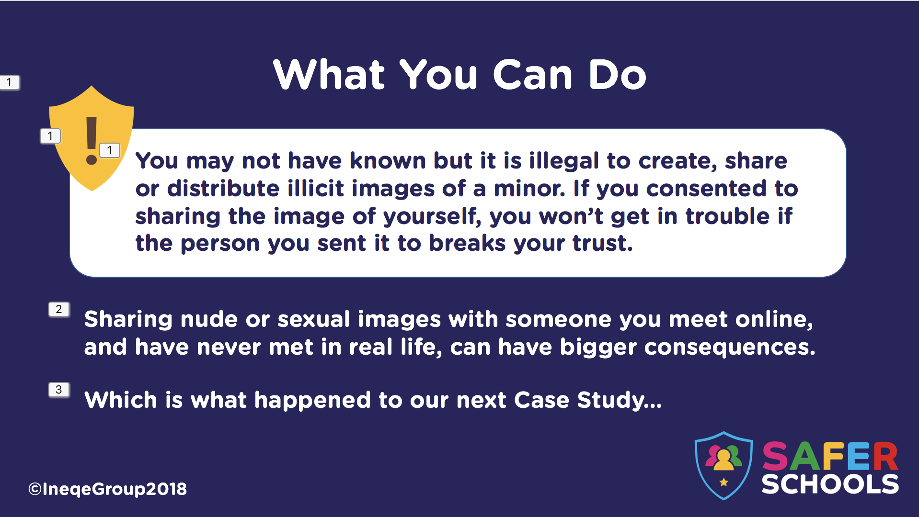 | Re-iterate that if an image they have shared by mutual consent, has been shared without their consent, they won’t get in trouble.  In 2016, police and the government in England and Wales implemented ‘Outcome 21’.  In order to decriminalise this issue, Outcome 21 states: “Further investigation, resulting from the crime report, which could provide evidence sufficient to support formal action being taken against the suspect is not in the public interest. This is a police decision.”  This means that police will treat youth-produced sexual imagery primarily as a safeguarding issue and allows the police discretion to not take further action if it’s not in the public interest.  NB: Teachers, Parents, Carers and Pupils can find more information on ‘Consent’ in the ‘Digital Images’ section of the Safer Schools App.
NOTES:
___________________________________________________________________________
___________________________________________________________________________
_____________________________________________________________________________________________________________________________________________________________________________________________________________________________________________________________________________________________________________________________________________________________________________________________________________________________________________________________________________________________________________________________________________

Slide 10 – Case Study 2
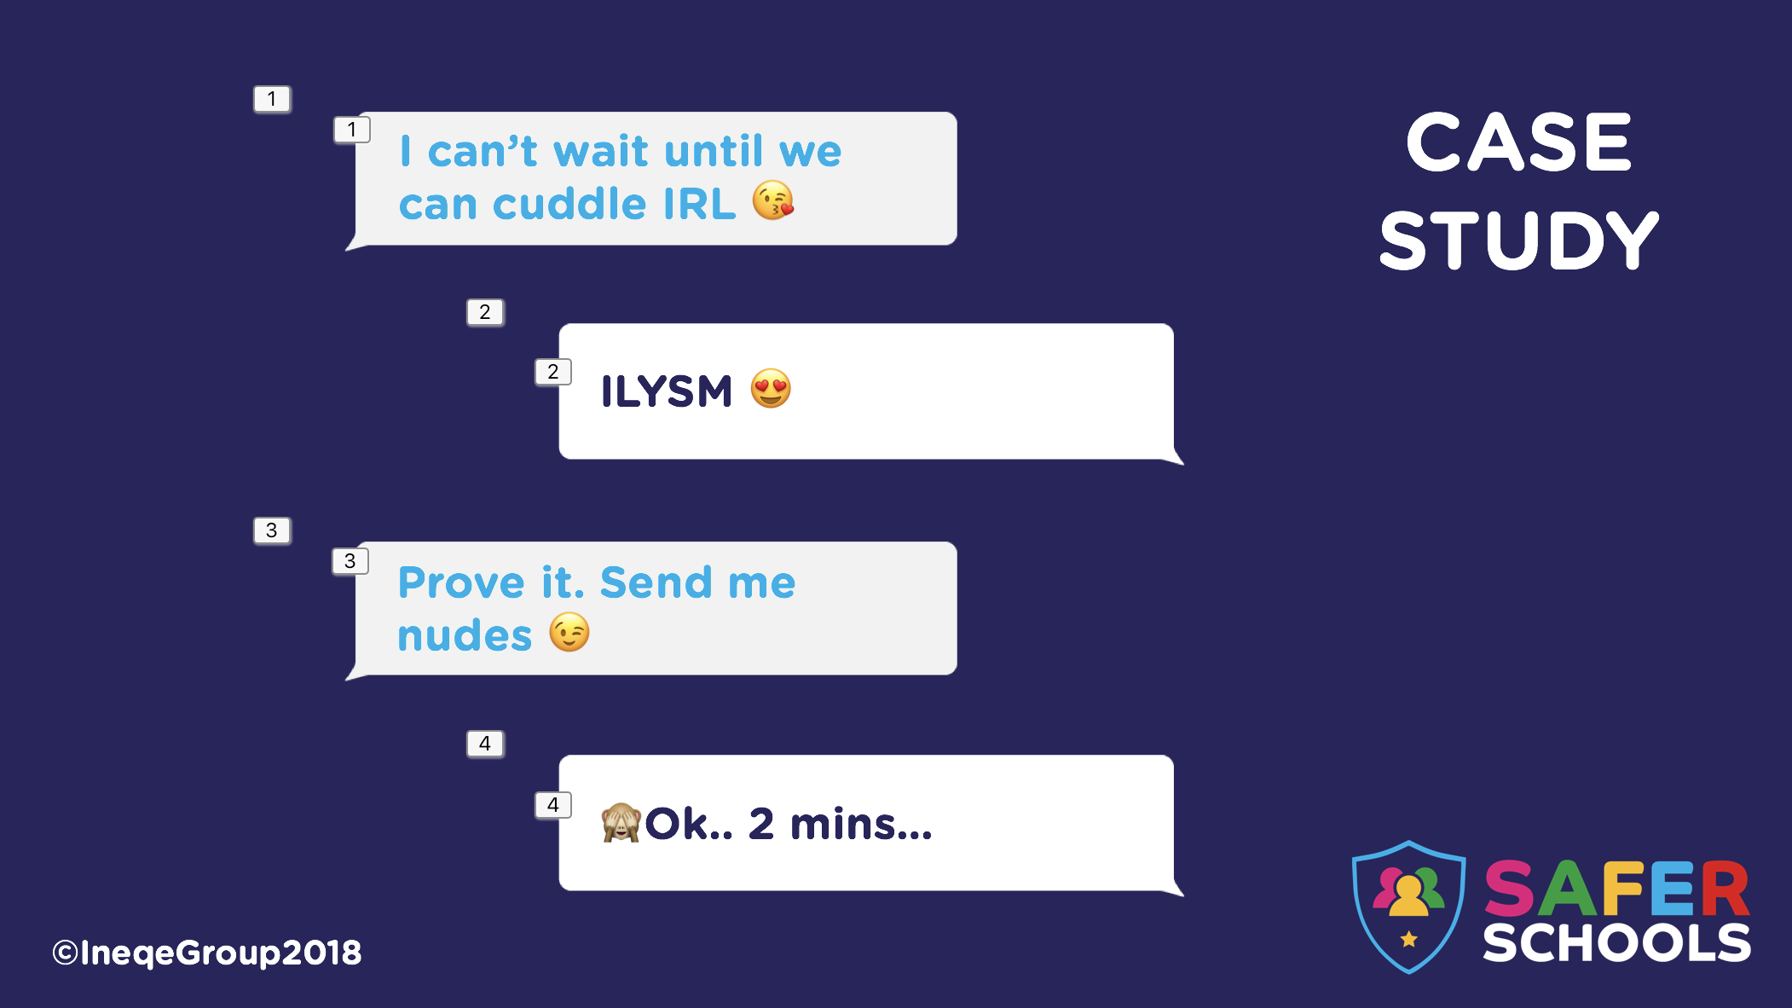 | Case study 2 deals with Sextortion.  This slide shows chat messages where one person is encouraging another to send nudes.  Each message pops up with separate clicks.  - I can’t wait until we can cuddle IRL (In Real Life).  - ILYSM (I Love You So Much)  - Prove it. Send me nudes  - Ok.. 2 mins  NB: Lower Secondary Pupils DO NOT have access to ‘Sextortion information in their Safer Schools App but Teachers, Parents, Carers and older pupils do.
NOTES:
___________________________________________________________________________
___________________________________________________________________________
___________________________________________________________________________________________________________________________________________________________________________________________________________________________________________________________________________________________________________________________________________________________________________________________________________________________________________________________________________________________________________________________________________________________________________________________________________________________________________________________________________________________________

Slide 11 – What happened
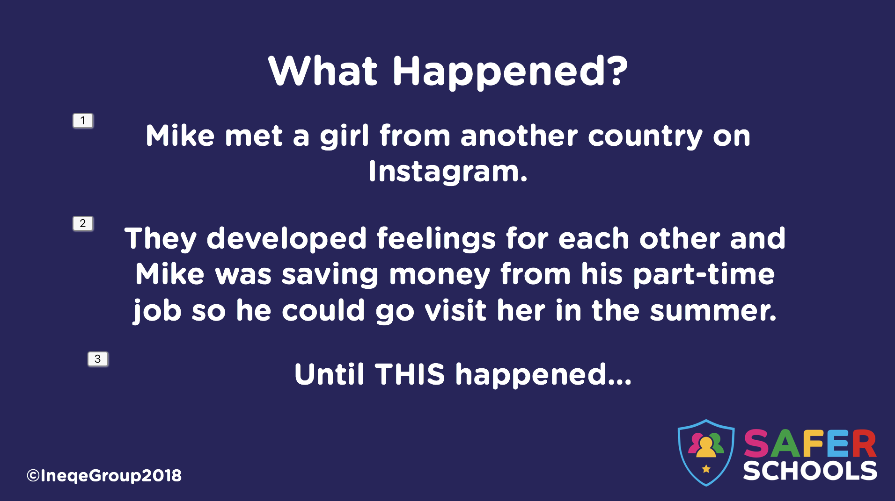 | This slide provides more context to the case study.  Each point appears with separate clicks.  - Mike met a girl from another country on Instagram.  - They developed feelings for each other and Mike was saving money from his part-time job so he could go visit her in the summer.  - Until this happened…  Prompt: Say ‘Mike thought it was real – if it seems too good to be true, it usually is.
NOTES:
___________________________________________________________________________
___________________________________________________________________________
___________________________________________________________________________________________________________________________________________________________________________________________________________________________________________________________________________________________________________________________________________________________________________________________________________________________________________________________________________________________________________________________________________________________________________________________________________________________________________________________________________________________________
______________________________________________________________________________________________________________________________________________________

Slide 12 – Case Study 2 continued
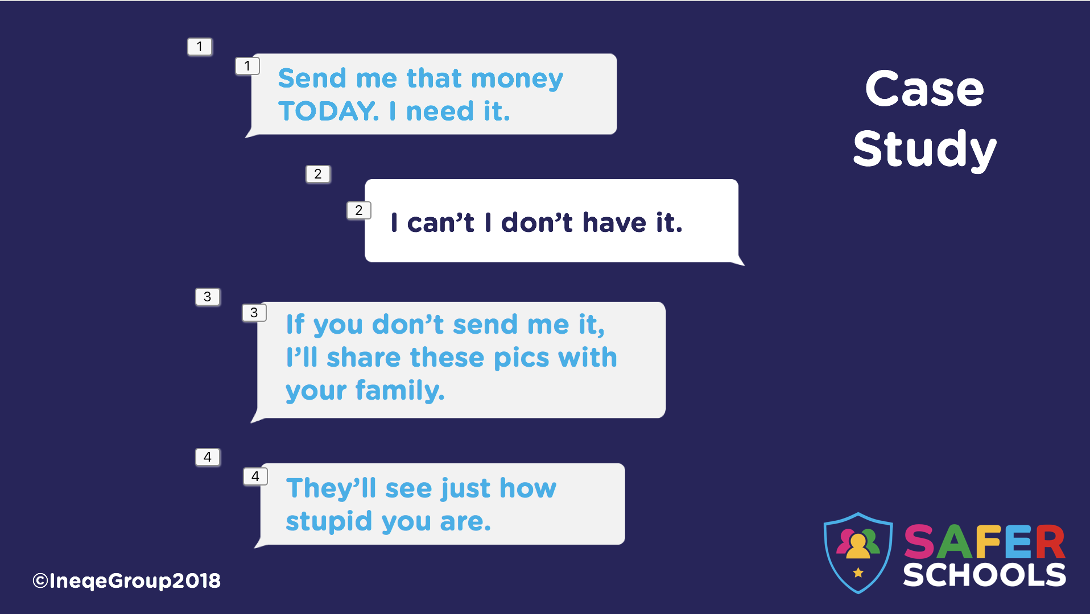 | This slide shows chat messages where one user is blackmailing the other regarding their previously sent nude images  Each message pops up with separate clicks.  - Send me that money TODAY. I need it.  - I can’t I don’t have it.  - If you don’t send me it, I’ll share these pics with your family.  - They’ll see just how stupid you are.

NOTES:
___________________________________________________________________________
___________________________________________________________________________
__________________________________________________________________________________________________________________________________________________________________________________________________________________________________________________________________________________________________________________________________________________________________________________________________________________________________________________________________________________________________________________________________________________________________________________________________________________________________________________________________________________________________________________________________________________________________________________________________________________________________________________________________________________________________________________________________________________________________________________________________________________________________________________________________________________________
Slide 13 – What happened
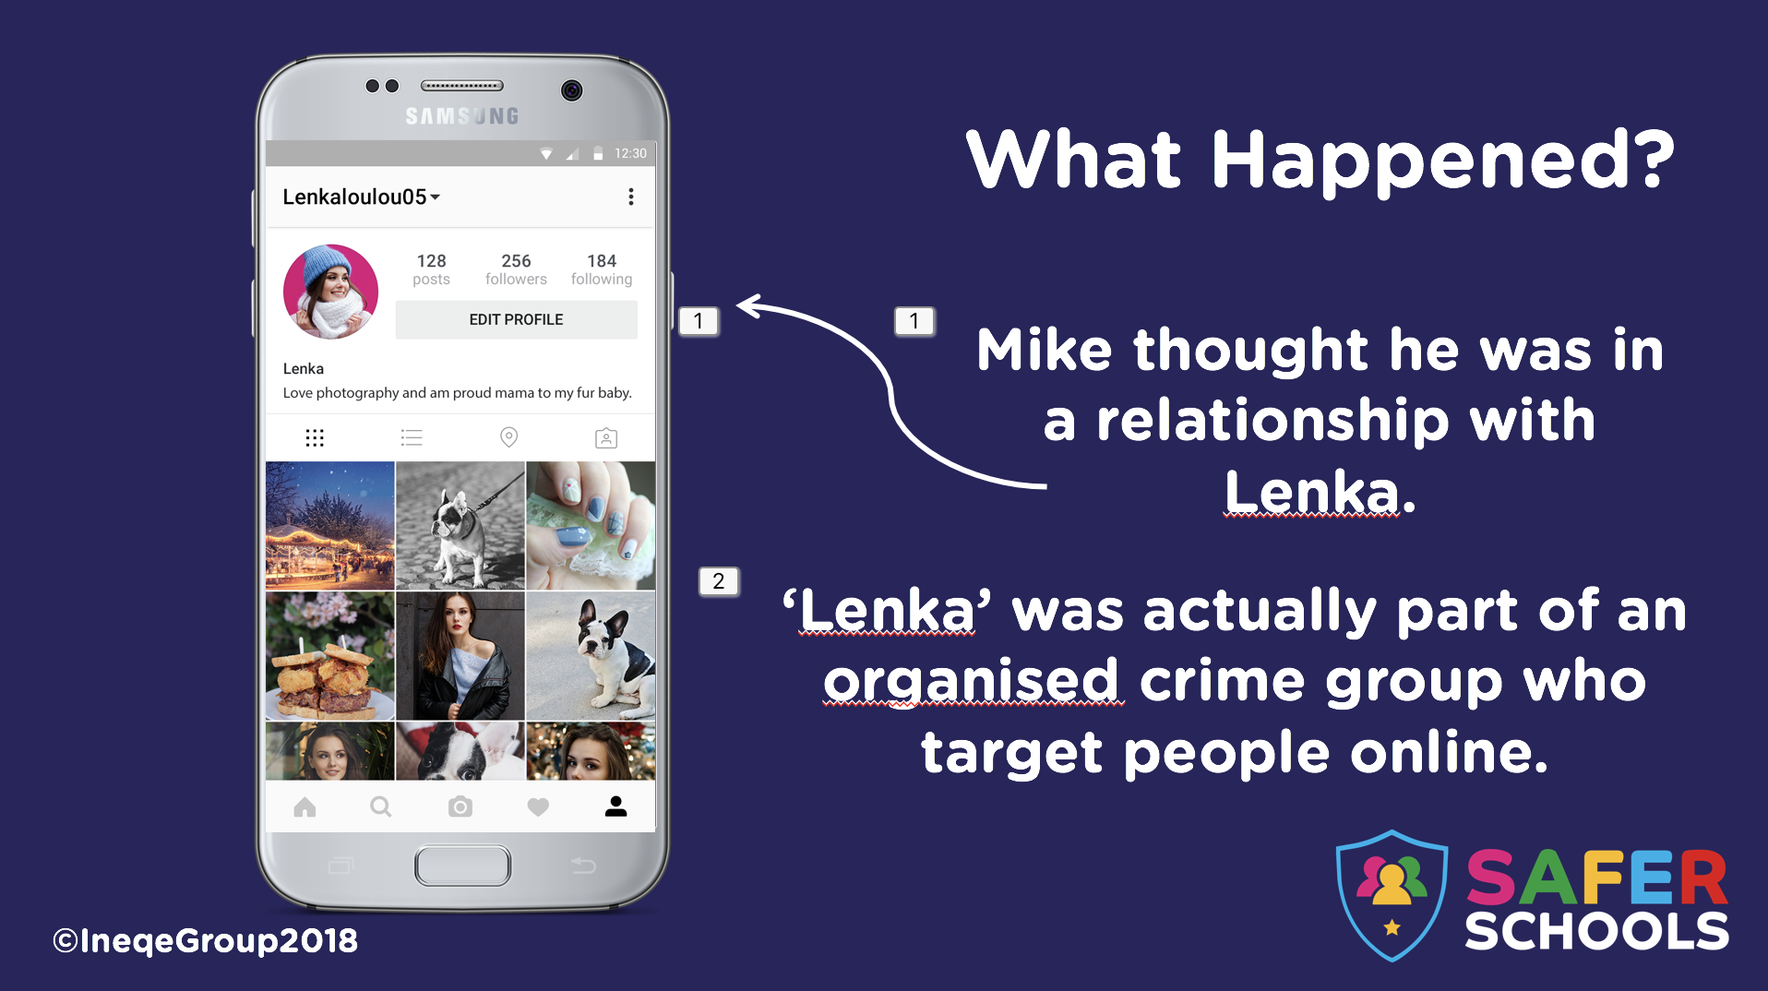 | Please Note: This is a hypothetical Instagram profile we created with images from a stock website.  Each point pops up with separate clicks.  - Mike thought he was in a relationship with Lenka.  - Lenka was actually being used by an organised crime group who target people online.  It’s important to note here that ‘Lenka’ may very well be a real person, who can send pictures of herself, video chat and talk on the phone.  However, her intentions may be suspect. She could be talking to many people at once, trying to trick them into sending her money.
NOTES:
___________________________________________________________________________
___________________________________________________________________________
___________________________________________________________________________________________________________________________________________________________________________________________________________________________________________________________________________________________________________________________________________________________________________________________________________________________________________________________________________________________________________________________________________________________________________________________________________________________________________________________________________________________________
Slide 14 – Discussion
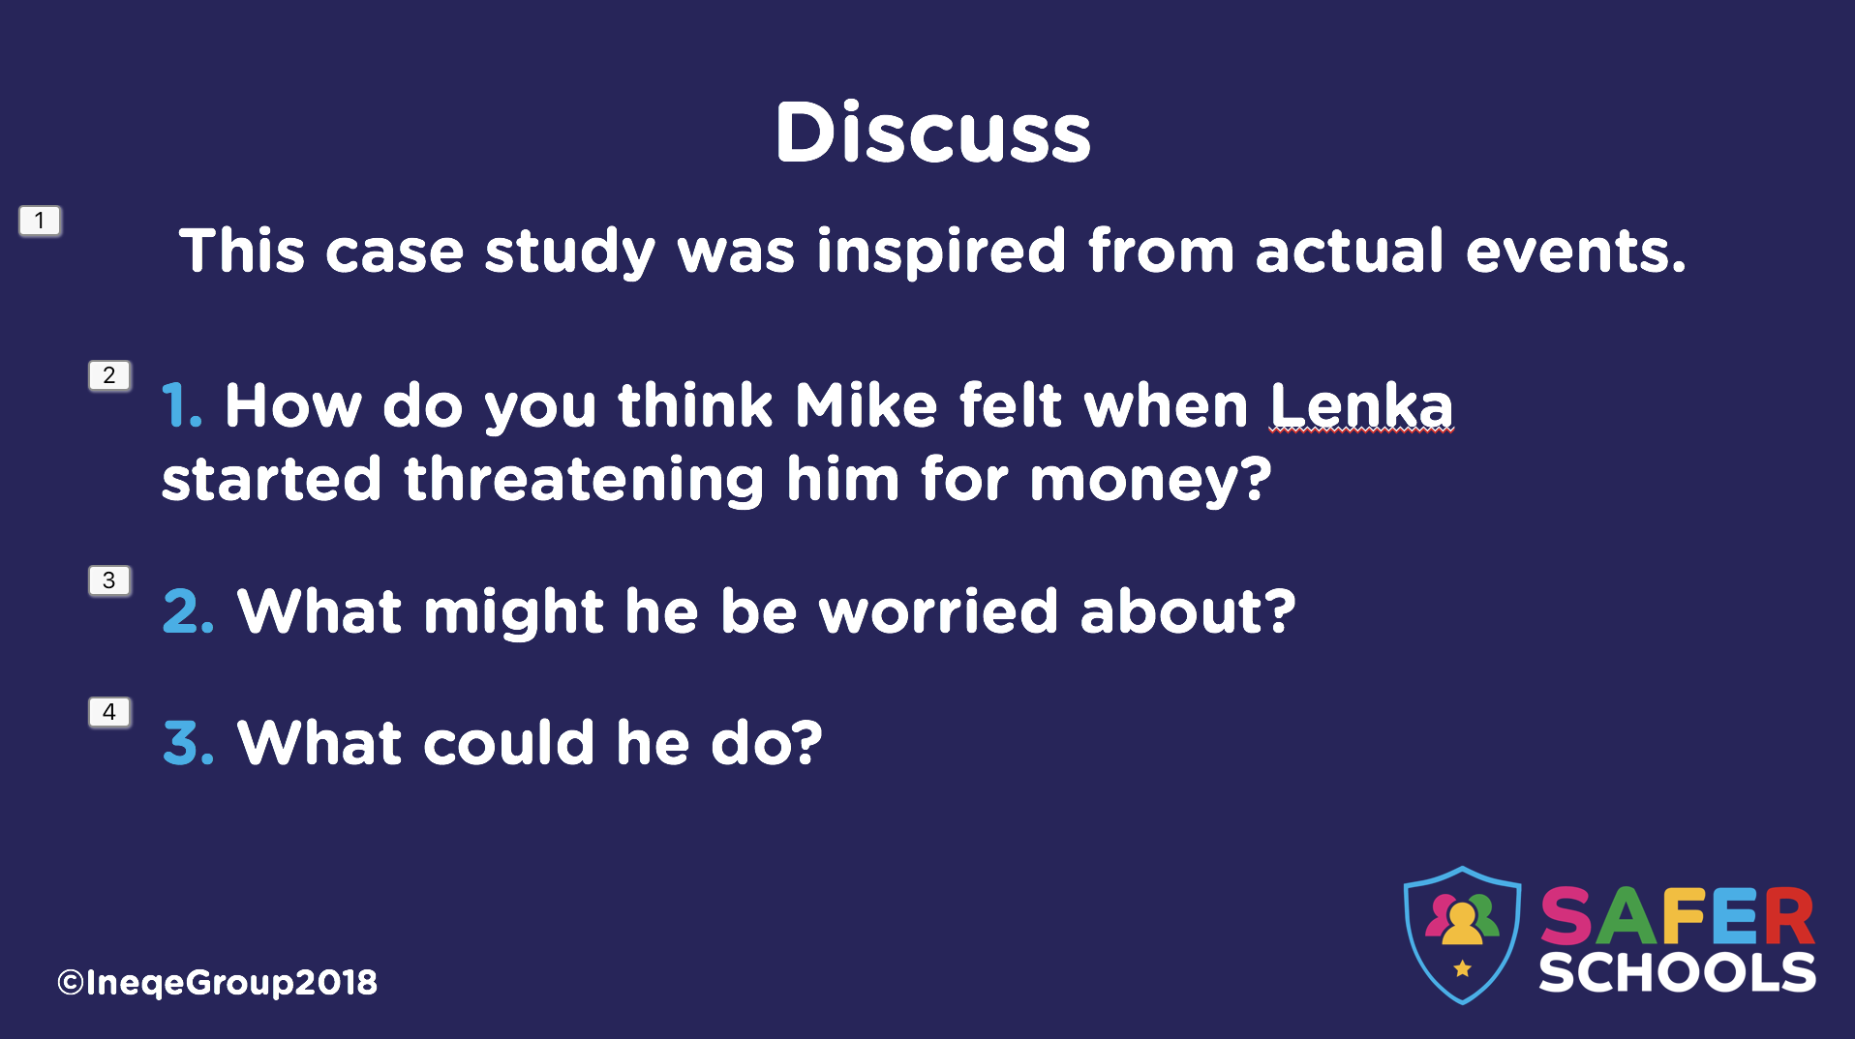 | This slide gives pupils the opportunity to discuss issues surrounding Sextortion.  Each point pops up with separate clicks.  - How do you think Mike felt when Lenka was threatening him for money?  - Scared, Upset, Heartbroken etc.  - What might he be worried about?  - Not having the money for her, that his parents would find out, that his private images would be publicly shared.  - What could he do?  - Tell an adult he trusts right away.
NOTES:
___________________________________________________________________________
___________________________________________________________________________
___________________________________________________________________________________________________________________________________________________________________________________________________________________________________________________________________________________________________________________________________________________________________________________________________________________________________________________________________________________________________________________________________________________________________________________________________________________________________________________________________________________________________
_________________________________________________________________________________________________________________________________________________________________________________________________________________________________
___________________________________________________________________________
Slide 15 – What you can do
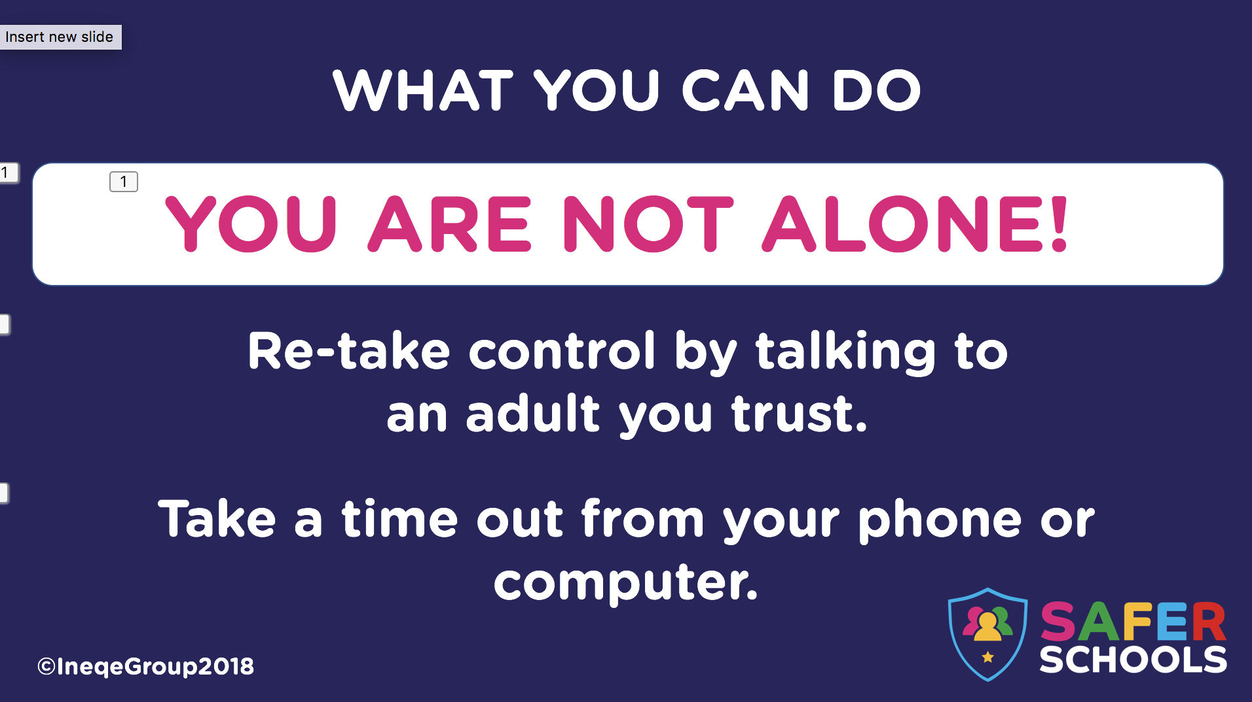 | Reinforce that blackmail is illegal and if pupils find themselves in this situation, they need to talk to an adult they trust right away.  Also reinforce that everyone makes mistakes at times in their lives and that the important thing about making mistakes is how you learn from them.
NOTES:
___________________________________________________________________________
___________________________________________________________________________
___________________________________________________________________________________________________________________________________________________________________________________________________________________________________________________________________________________________________________________________________________________________________________________________________________________________________________________________________________________________________________________________________________________________________________________________________________________________________________________________________________________________________
__________________________________________________________________________________________________________________________________________________________________________________________________________________________________________________________________________________________________________________________________________________________________________________________________________________________________________________________________

Slide 16 – Case Study 3
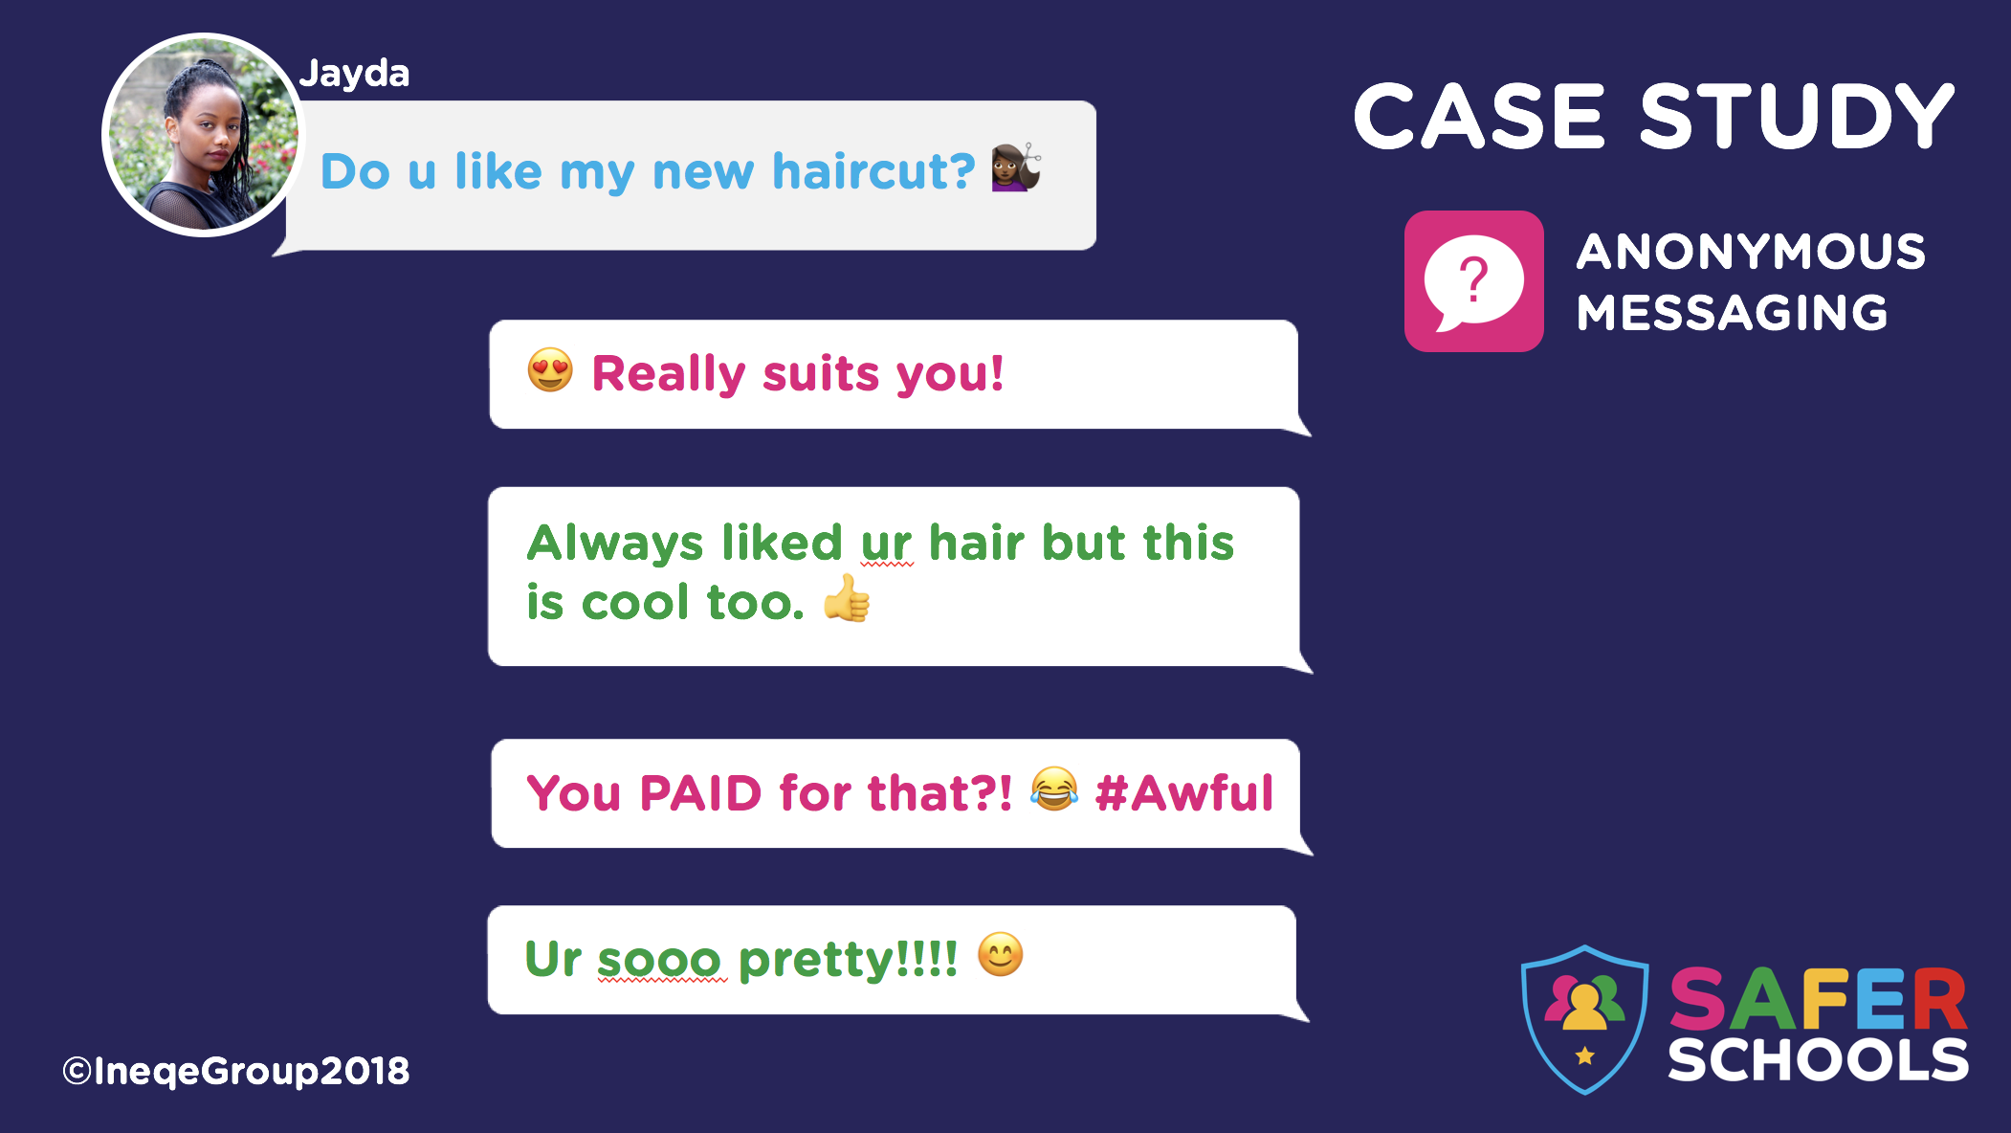 | Case Study 3 outlines Anonymous messaging. Research shows that while children and young people are becoming aware of the dangers lurking online, they are not always aware of how to manage their emotions, especially when they see something which upsets them.  NB: Teachers, Parents and Carer can find more information on ‘Anonymous Messaging’ Apps in the ‘Social Media’ section of the Safer Schools App.  Pupils do not currently have information on this.
NOTES:
___________________________________________________________________________
___________________________________________________________________________
___________________________________________________________________________________________________________________________________________________________________________________________________________________________________________________________________________________________________________________________________________________________________________________________________________________________________________________________________________________________________________________________________________________________________________________________________________________________________________________________________________________________________
_________________________________________________________________________________________________________________________________________________________________________________________________________________________________

Slide 17 – What happened
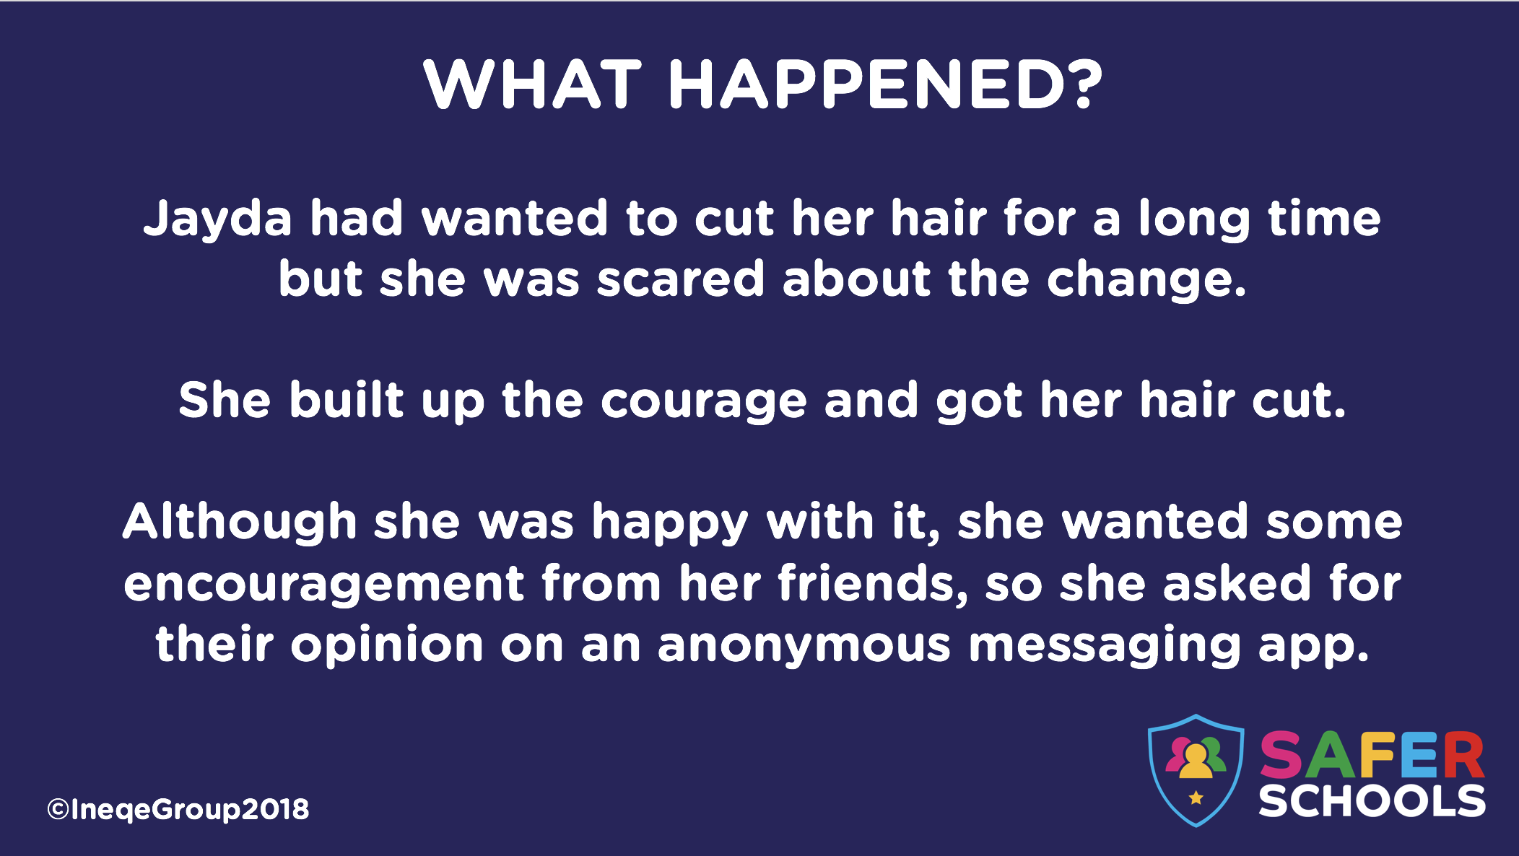 | This slide outlines why Jayda sent a message.  Anonymous messaging is a constant source of online bullying. Parents and Staff can find more information on this in the Safer Schools App (pupils do not have access to this content)
NOTES:
___________________________________________________________________________
___________________________________________________________________________
_____________________________________________________________________________________________________________________________________________________________________________________________________________________________________________________________________________________________________________________________________________________________________________________________________________________________________________________________________________________________________________________________________________________________________________________________________________________________________________________________________________________________________________________________________________________________________________________________________________________________________________________________________________________________________________________________________________________________________________________________________________________________________________________________________________________________________________________________________________________________________

Slide 18 – What happened
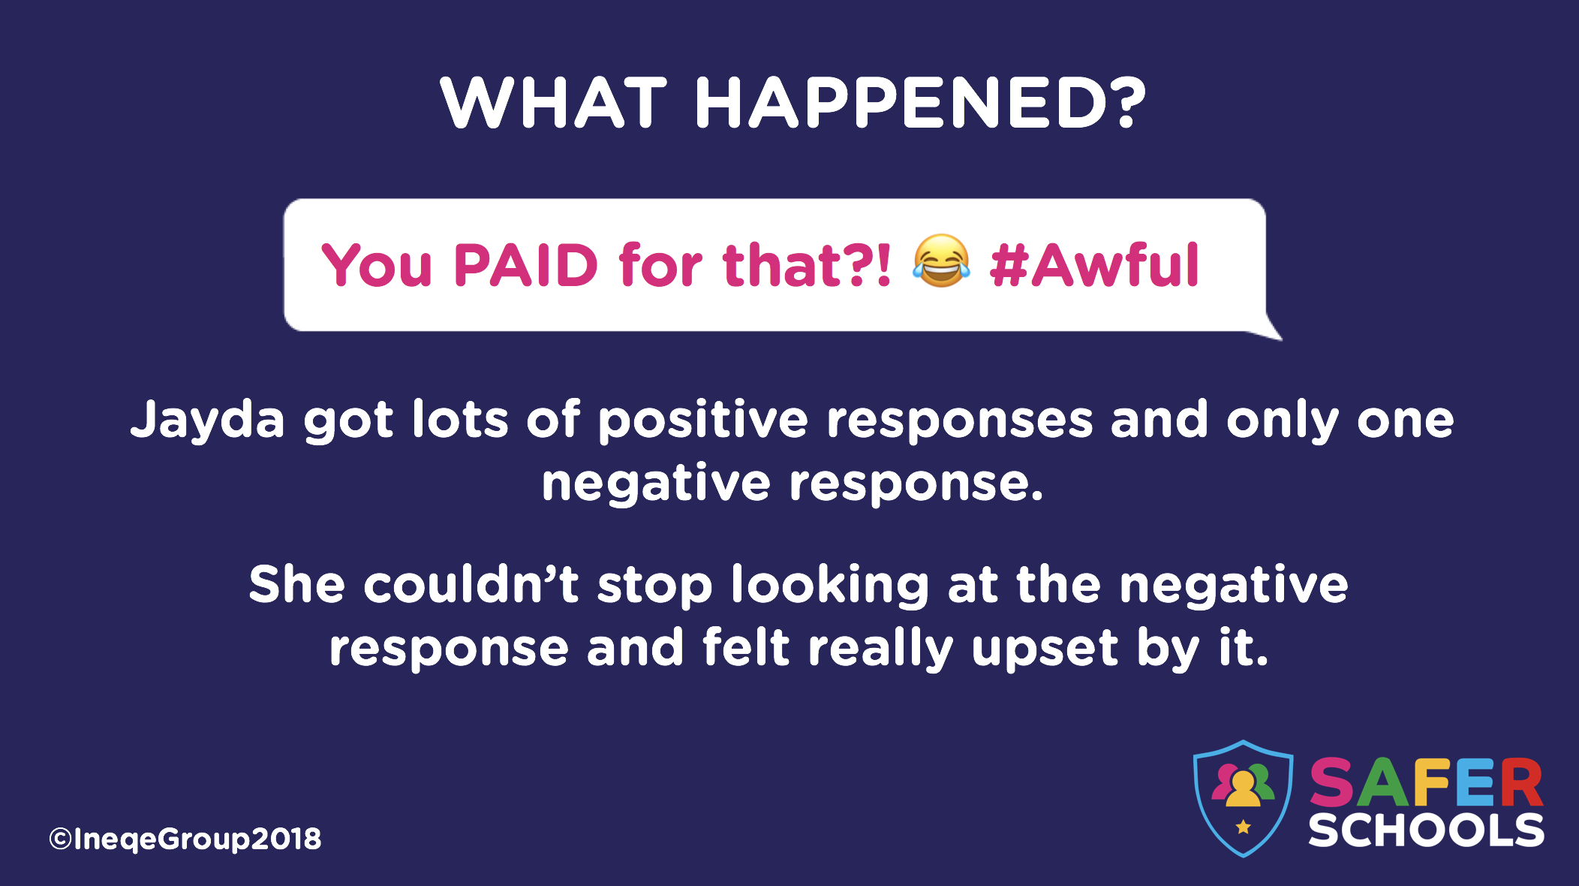 | This slide highlights how Jayda focused on the one negative comment rather than the positive ones.
NOTES:
___________________________________________________________________________
___________________________________________________________________________
___________________________________________________________________________________________________________________________________________________________________________________________________________________________________________________________________________________________________________________________________________________________________________________________________________________________________________________________________________________________________________________________________________________________________________________________________________________________________________________________________________________________________
__________________________________________________________________________________________________________________________________________________________________________________________________________________________________________________________________________________________________________________________________________________________________________________________________________________________________________________________________
Slide 19 - Discuss
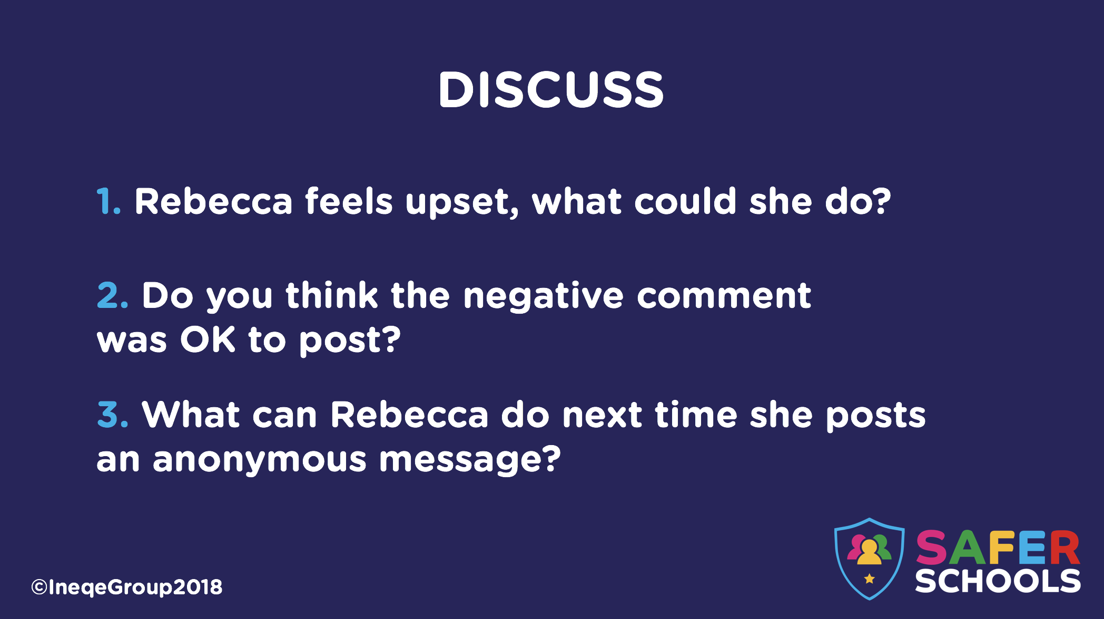 | This slide gives pupils the opportunity to discuss issues surrounding what to do when they see something that upsets them, whether they should say negative things online and how they can protect themselves from hurtful comments online.
NOTES:
___________________________________________________________________________
___________________________________________________________________________
___________________________________________________________________________________________________________________________________________________________________________________________________________________________________________________________________________________________________________________________________________________________________________________________________________________________________________________________________________________________________________________________________________________________________________________________________________________________________________________________________________________________________
_______________________________________________________________________________________________________________________________________________________________________________________________________________________________________________________________________________________________________________________________________________________________________________________
______________________________________________________________________________________________________________________________________________________

Slide 20
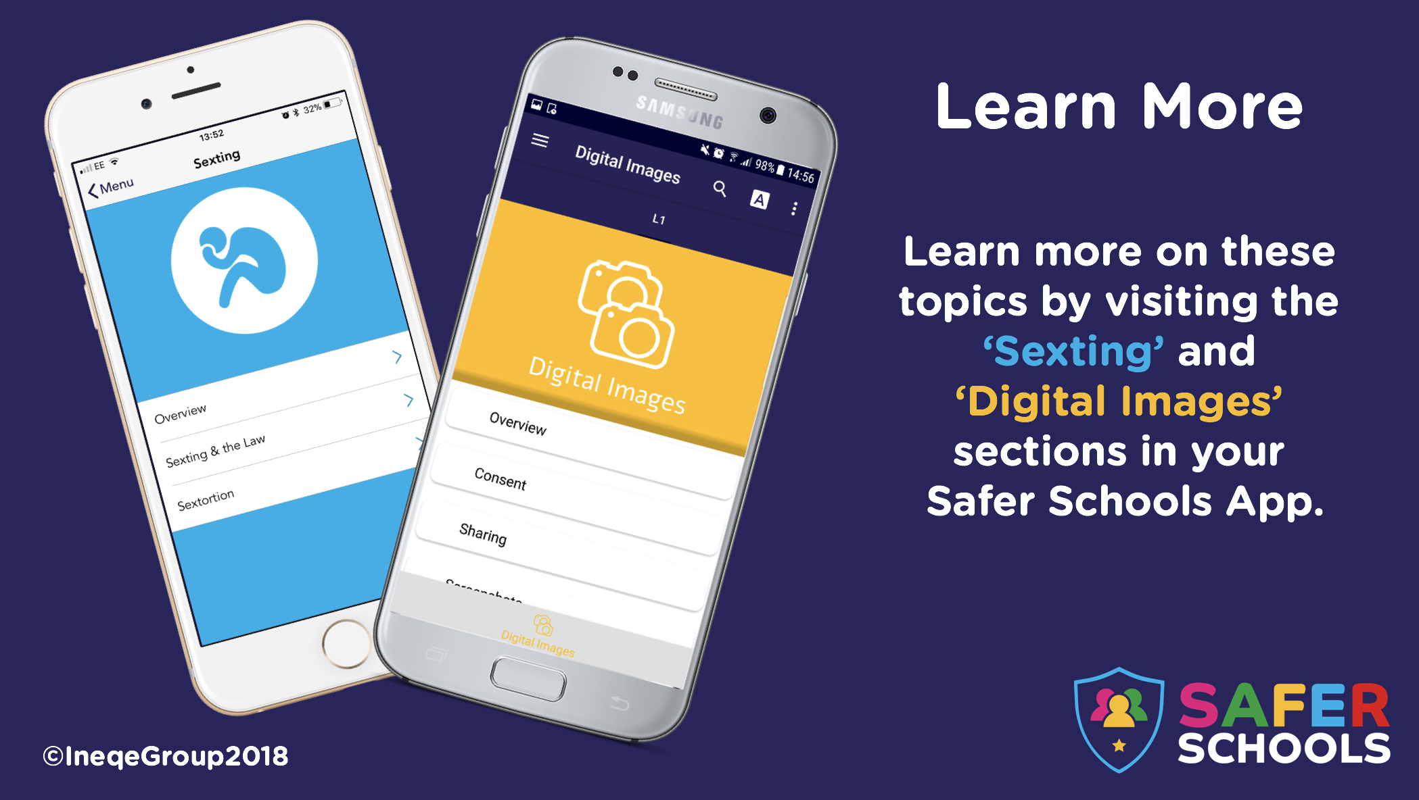 | Encourage pupils to explore these topics more through the relevant sections in their safer schools app.
NOTES:
___________________________________________________________________________
___________________________________________________________________________
___________________________________________________________________________________________________________________________________________________________________________________________________________________________________________________________________________________________________________________________________________________________________________________________________________________________________________________________________________________________________________________________________________________________________________________________________________________________________________________________________________________________________
_______________________________________________________________________________________________________________________________________________________________________________________________________________________________________________________________________________________________________________________________________________________________________________________
______________________________________________________________________________________________________________________________________________________

https://www.safeguardinginschools.co.uk/responding-sexting-schools-colleges-ukccis/

